One mark questions
      - a. What is deep learning
Deep Learning is a subfield of machine learning concerned with algorithms inspired by the structure and function of the brain called artificial neural networks.

2. What is the need for validation data in deep learning?
The validation data set is used to measure how well our model is generalizing and for tuning the hyper parameters

b. what are the limitations of linear neurons
- The function’s derivative is a constant. That means there is constant gradient descent.
- Since the activation is linear, nesting in 2 or N number of hidden layers with the same function will have no real effect.

c. List any 4 applications of deep learning
- Self Driving Cars.
- News Aggregation and Fraud News Detection.
- Natural Language Processing.
- Virtual Assistants.
- Automatic hand writing recognition
- Automatic game playing
- Health care

d. Mention any 4 deep learning frameworks or tools
TensorFlow
Keras
PyTorch
Sonnet
DL4J

What are hyper parameters in neural networks
Parameters other than weights and biases.
Hyperparameters are the variables which determines the network structureand the variables which determine how the network is trained.

They are- no. of hidden units, no.of nodes in each layer, learning rate, no,of epochs etc

What are Hyper parameters in cnn

Stride, padding, no, of filters, mini batch size

What is overfitting?

- It refers to the phenomenon where a neural network models the training data very well but fails when it sees new data from the same problem domain.
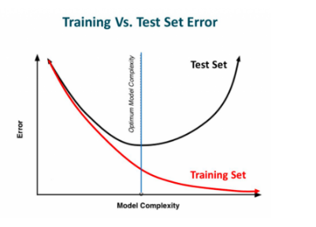

Over fitting is caused by noise in the training data that the neural network picks up during training and learns it as an underlying concept of the data. Avoiding over fitting can single-handedly improve our model’s performance

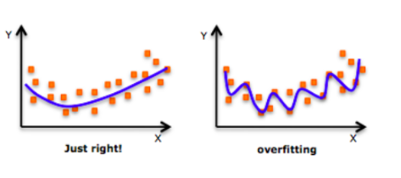

e. List out the methods of preventing over fitting in deep learning
Regularization, Dropout

What is an epoch
An epoch is a single iteration over the entire training set. In other words, if we have a
training set of size d and we are doing mini-batch gradient descent with batch size b,
then an epoch would be equivalent to d/b model updates. At the end of each epoch, we
want to measure how well our model is generalizing.

What is regularization.
Regularization modifies the objective function that we minimize by adding additional terms that penalize large weights. In other words, we change the objective function so that it becomes

Error + λ f (θ ) where λ is the regularization strength,

What is L2 regularization- (or) what is weight decay?
For every weight w in the neural network, we add 1/2λw² to the error function. During the gradient descent update, using the L2 regularization ultimately
means that every weight is decayed linearly to zero. Because of this phenomenon, L2 regularization is also commonly referred to as weight decay

what is L1 regularization-
we add the term λ|w| for every weight w in the neural network. neurons with L1 regularization
end up using only a small subset of their most important inputs and become quite
resistant to noise in the inputs.

What do you mean by Max norm constraints
Max norm constraints enforce an absolute upper bound on the magnitude of the incoming weight vector for every neuron and use projected gradient descent to enforce the constraint. One of the nice properties is that the parameter vector cannot grow out of control (even if the learning rates are too high) because the updates to the weights are always bounded.

What is Dropout

Dropout- While training, dropout is implemented by only keeping a neuron active with some probability p (a hyperparameter), or setting it to zero otherwise.

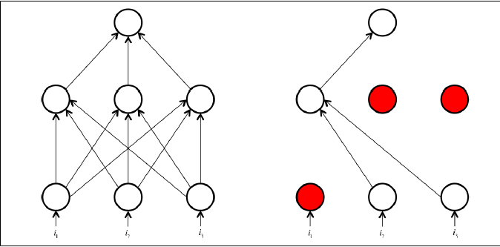

Here, a neuron’s output is set to 0 with probability 1 − p.
This means that if a neuron’s output prior to dropout was x, then after dropout, the expected output would be

E [output] = px + (1 – p). 0 = px.

What is Inverted dropout:

In inverted dropout, scaling occurs at training time instead of at test time. In inverted dropout, any neuron whose activation hasn’t been silenced has its output divided by p before the value is propagated to the next layer., 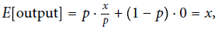

What is the need of Validation set in deep learning?

In machine learning , if our model is very complex we run the risk of overfitting.
Deep learning takes the approach of solving very complex problems with complex models and taking additional countermeasures to prevent overfitting.
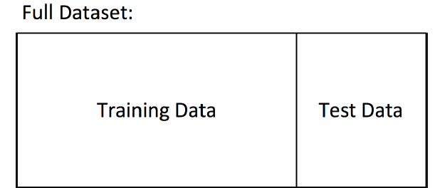

By dividing our data into train and test sets, the model measuring how well it generalizes on new data it has not yet seen. It’s quite likely that while we’re training our data, there’s a point in time where instead of learning useful features, we start overfitting to the training set.

To avoid that, we want to be able to stop the training process as soon as we start overfitting, to prevent poor generalization. To do this, we divide our training process into epochs..
At the end of each epoch, we want to measure how well our model is generalizing. To do this, we use an additional validation set.
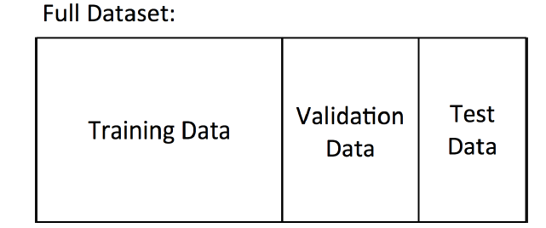
At the end of an epoch, the validation set will tell us how the model does on data it has yet to see. If the accuracy on the training set continues to increase while the accuracy on the validation set stays the same (or decreases), it’s a good sign that it’s time to stop training because we’re overfitting.

The validation set is also helpful as a proxy measure of accuracy during the process of hyperparameter optimization (hyperparameter -learning rate, minibatch size, etc.).

- What is cnn and its applications?

Convolutional Neural Network is an artificial deep learning neural network. It is used for computer vision/image recognition. This process includes the following operations:
- Image recognition and OCR
- Object detection for self-driving cars
- Face recognition on social media
- Image analysis in healthcare

- What is convolution?

A convolution operation is an element wise matrix multiplication operation. Where one of the matrices is the image, and the other is the filter or kernel that turns the image into something else. The output of this is the final convoluted image.

- What is the use of padding? (or) what is padding?
Every time we apply a convolutional operation, the size of the image shrinks
Pixels present in the corner of the image are used only a few number of times during convolution as compared to the central pixels. Hence, we do not focus too much on the corners since that can lead to information loss. To overcome these issues, we can pad the image with an additional border, i.e., we add one pixel all around the edges

- What is Striding
No of steps taken for convolution. Suppose we choose a stride of 2. So, while convoluting through the image, we will take two steps – both in the horizontal and vertical directions separately. Stride helps to reduce the size of the image, a particularly useful feature

- What is the use of pooling and types

Pooling layers are generally used to reduce the size of the inputs and hence speed up the computation.
Max pooling,min pooling, average pooling

- What is an autoencoder and its applications

An autoencoder is a type of artificial neural network used to learn efficient data codings in an unsupervised manner. The aim of an autoencoder is to learn a representation (encoding) for a set of data, typically for dimensionality reduction, by training the network to ignore signal “noise.
- Autoencoders are a specific type of feedforward neural networks where the input is the same as the output.
They compress the input into a lower-dimensional code and then reconstruct the output from this representation

- What is bottleneck?

The layer between the encoder and decoder, ie. the code is also known as Bottleneck

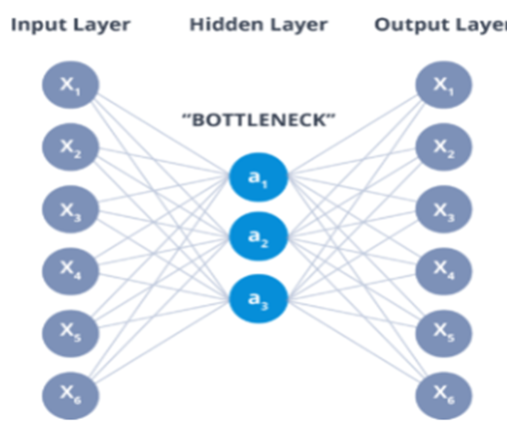
- Applications of Autoencoders
Dimensionality Reduction
Image Compression
Image Denoising
Feature Extraction
Image generation
Sequence to sequence prediction
Recommendation system

What are the Hyperparameters of Autoencoders
- Code size: It represents the number of nodes in the middle layer. Smaller size results in more compression.
- Number of layers: The autoencoder can consist of as many layers as we want.
- Number of nodes per layer: The number of nodes per layer decreases with each subsequent layer of the encoder, and increases back in the decoder. The decoder is symmetric to the encoder in terms of the layer structure.
- Loss function: We either use mean squared error or binary cross-entropy. If the input values are in the range [0, 1] then we typically use cross-entropy, otherwise, we use the mean squared error.

Comparision : PCA versus AutoEncoders
- PCA is a linear transformation of data while AE can be linear or non-linear depending on the choice of the activation function.
- PCA is pretty fast as there exist algorithms that can fast calculate it while AE trains through Gradient descent and is slower comparatively.
- PCA projects data into dimensions that are orthogonal to each other resulting in very low or close to zero correlation in the projected data. AE transformed data doesn't guarantee that because the way it’s trained is merely to minimize the reconstruction loss.
- PCA is a simple linear transformation on the input space to directions of maximum variation while AE is a more sophisticated and complex technique that can model relatively complex relationships and non-linearities.
- One rule of thumb could be the size of Data. Go with PCA for small datasets and AE for comparatively larger datasets.
- PCA hyperparameter is ‘k’ i.e. number of orthogonal dimensions to project data into while for AE it is the architecture of the neural network.
- AE with a single layer and linear activation has similar performance as PCA. AE with multiple layers and non-activation function termed as Deep Autoencoder is prone to overfitting and can be controlled by Regularisation and careful designing.

Auto encoder diagrams

PCa

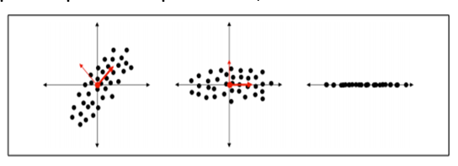

Dimensionality reduction with autoencoder
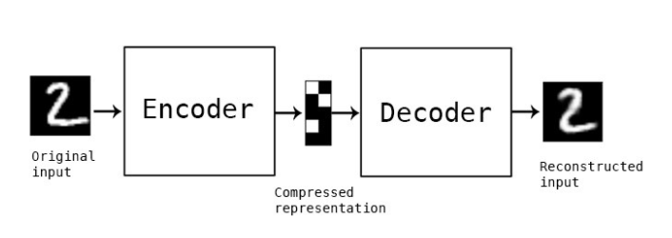
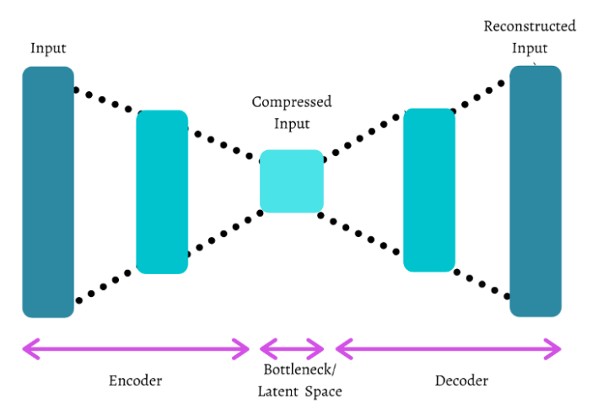

Diagram for Denoisy auto encoder

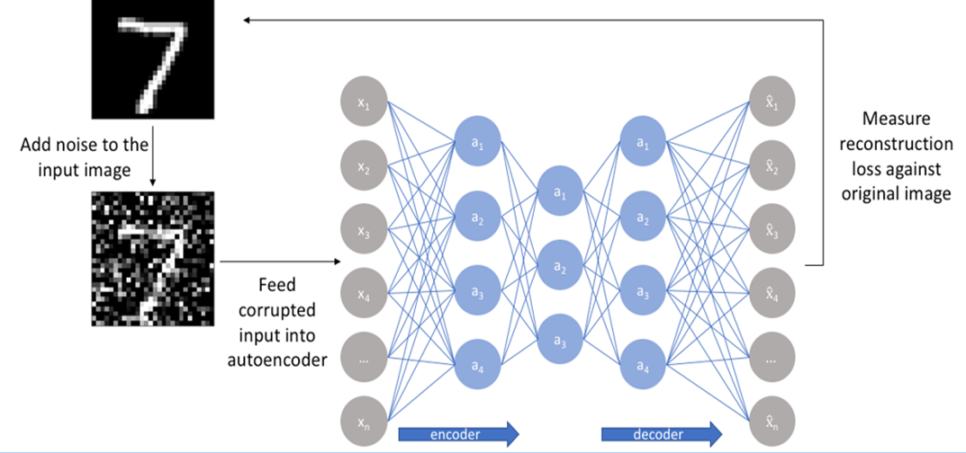

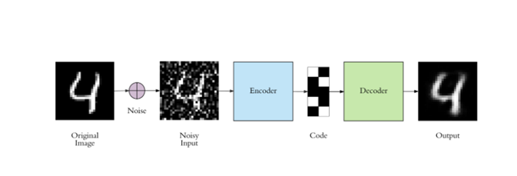

Diagrams for sparse autoencoders

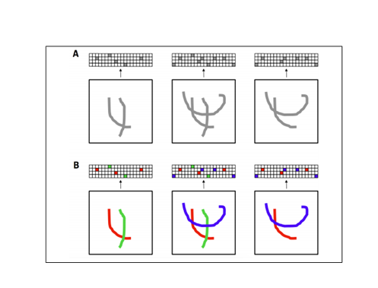
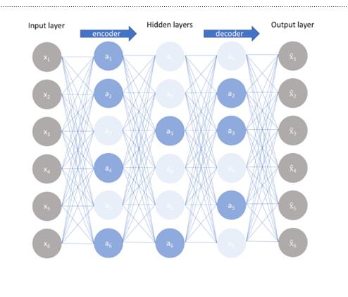
Diagram for auto encoder
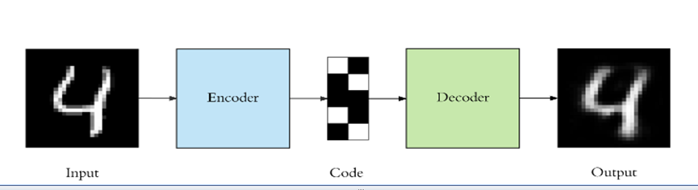
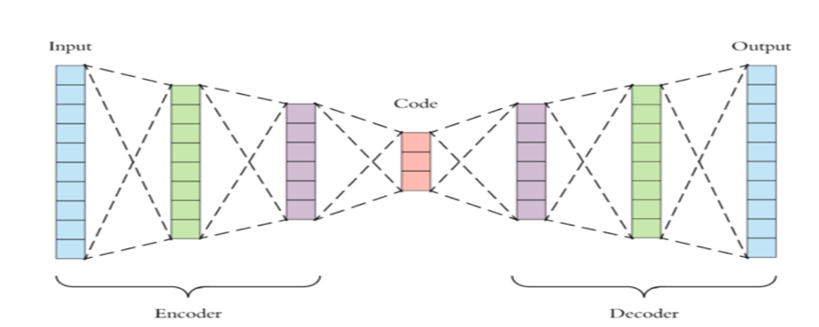

Applications of sequence modeling( RNN and LSTM)

  - Speech recognition (sequence to sequence):
  - Music generation (one to sequence):
Sentiment classification (sequence to one)
  - Machine translation from one language to another (sequence to sequence):

What is bPTT
- In RNN, States computed in the forward pass must be stored until they are reused during the backward pass,. The back-propagation algorithm applied to the unrolled graph is called back-propagation through time or BPTT

Stochastic and batch gradient descent

- batch gradient descent.
The idea behind batch gradient descent is that we use our entire dataset to compute the error surface and then follow the gradient to take the path of steepest descent.

- In Stochastic Gradient Descent (sometimes also referred to as iterative or on-line gradient descent) we update the weights after each training sample

Disadvantages of batch and stochastic
Batch- It is difficult for datasets that don't fit in memory. Batch gradient descent also doesn't allow us to update our model online, i.e. with new examples on-the-fly
Stochastic- SGD will keep overshooting, complicates convergence to the exact minimum and make gradient descent take a significant amount of time

Mini batch gradient descent

- Mini-batch gradient descent finally takes the best of both worlds and performs an update for every mini-batch of n training examples. Instead of summing over all the examples in the dataset, we sum over the examples in the current minibatch

